**ABC Call Volume Trend Analysis**

**DESCRIPTION:**

A customer Experience (CX) team plays a crucial role in a company. They analyse customer feedback and data, derive insights from it, and share these insights with the rest of the organization. This team is responsible for a wide range of tasks, including managing customer experience programs, handling internal communications, mapping customer journeys and managing customer data, among others.

In this project, we will be diving into the world of customer Experience analytics, specifically focusing on the inbound calling team of a company. We are provided with a dataset that spans 23 days and includes various details such as the agent’s name and ID, the queue time the time of a call, the duration of the call and the call status. We will be using our analytical skills to understand the trends in the call volume of the CX team and derive valuable insights from it.

**TECH STACK:**

* Python
* Microsoft Excel

**DATASET OVERVIEW**

The dataset provides details about the calls received by various agents like call duration, data and time of the call etc.

The dataset details are:

**1.Agent_Name**: Name of the Agent receiving the call.  
**2**. **Agent_ID**: ID number of the Agent receiving the call.  
**3**. **Customer_Phone_No**: Mobile number of the customer.  
**4**. **Queue_Time(Secs)**: Waiting time before receiving the call.

**5**. **Date_&_Time**: Date on which the call was made.

**6**. **Time:** Hour of the day in which the call was made.

**7**. **Time_Bucket**: The hourly time bucket in which the call was made.

**8**. **Duration(hh:mm:ss)**: Duration of the call in time format.  
**9**. **Call_Seconds (s)**: Duration of the call in seconds.

**10**. **Call_Status**: Whether the call was answered or transferred or abandoned.

**11**. **Wrapped _By**: Whether the call was cut by the agent or it was automatically cut.

**12**. **Ringing**: Whether the system gave a ring when the call was made.

**13**. **IVR _Duration**: Duration of Interactive Voice Response in seconds.

**DATASET PRE-PROCESSING:**

**Handling duplicate values:** Found the duplicate rows on analysis. Except the first instant dropped all other duplicate rows.

**Handling Null Values:** We found that all the rows where Agent_Name and Agent_ID was NULL are rows denoting abandoned calls.

Some calls where Wrapped_By was NULL were answered or transferred calls. So replaced them with value “Agent”.

Rest of the NULL values were replaced by value “Not Available”.

**Handling Errors:** As the below process shows that Customer_Phone_No column had rows with 5 digit number which is an error.

So we checked and found one such row and replaced the column value with ‘XXXXXXXXX’.

**Handling Outliers:** For outliers in Call_Seconds column, we plotted box plot and considered 3000 as the threshold value for being an Outlier. So, nothing was changed.

**INSIGHTS:**

**Average Call Duration:** Determine the average duration of all incoming calls received by agents. This should be calculated for each time bucket.

**Your Task:** What is the average duration of calls for each time bucket?

**Result:**

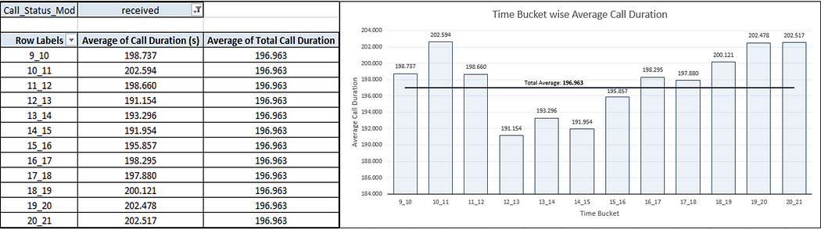

The overall Average Call Duration is 196.963 seconds.

We can observe that the Average Call Duration first peaks in the morning hours before dropping to below average value during the lunch hours and then again increasing to above average value.

**Call Volume Analysis:** Visualize the total number of calls received. This should be represented as a graph or chart showing the number of calls against time. Time should be represented in buckets (e.g., 1-2, 2-3, etc.).

**Your Task:** Can you create a chart or graph that shows the number of calls received in each time bucket?

**Result:**

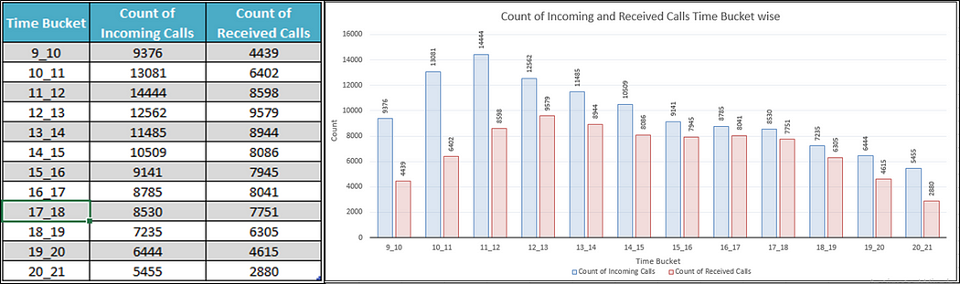

We can observe that the number of received calls received first increases with time before dropping down.

We can also observe that the number of abandoned calls are very high in the morning hours and as the day progresses, the number of abandoned calls reduces.

**Manpower Planning:** The current rate of abandoned calls is approximately 30%. Propose a plan for manpower allocation during each time bucket (from 9 am to 9 pm) to reduce the abandon rate to 10%. In other words, you need to calculate the minimum number of agents required in each time bucket to ensure that at least 90 out of 100 calls are answered.

**Your Task:** What is the minimum number of agents required in each time bucket to reduce the abandon rate to 10%?

**Result:**

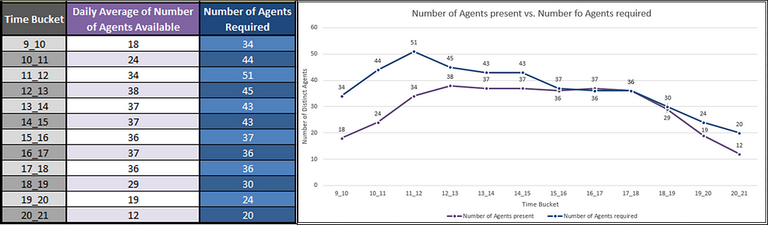

We can observe that to maintain a maximum of 10% abandon rate, we need to increase the availability of agents in the morning hours by a large margin as in these hours, the number of incoming calls are quite high and the number of agents available currently are quite low.

During **afternoon** **hours** and during  **late** **evening** **hours**, we need to **increase** the availability of agents by a **slight** **margin** to maintain a maximum of **10% abandon rate**.

**Night Shift Manpower Planning:** Customers also call ABC Insurance Company at night but don't get an answer because there are no agents available. This creates a poor customer experience. Assume that for every 100 calls that customers make between 9 am and 9 pm, they also make 30 calls at night between 9 pm and 9 am. The distribution of these 30 calls is as follows:

**Your Task:** Propose a manpower plan for each time bucket throughout the day, keeping the maximum abandon rate at 10%.

**Result:**

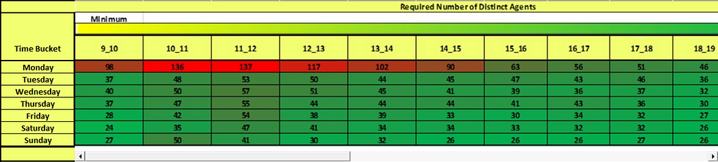

From the above heatmap, we can observe that for days of the week, Monday requires the most number of agents in individual time buckets as well as for the overall day as it is starting of the week.

For rest of the days, agents requirement remains more or less the same with Saturday’s and Sunday’s requirement on the lower side as they are weekends.

For individual time buckets the most number of agents required is in the morning hours from 9 A.M to 1 P.M and the least number of agents required is at night hours from 12 A.M to 5 P.M.

**CONCLUSION:**

In this project I was able to get insights like call abandon rates, distribution, number of calls, agents, how to create a manpower plan so as to decrease abandon calls etc. I also got experience in Data Pre-processing like data cleaning and handling outliers, Feature Engineering etc. in this project. I can now communicate the insights to relevant stakeholders as per the requirements.